Chapter 1 Introducing science

🐧Penguin’s notes🐧

1.1 Learning about science
What is science?
- The study of phenomena and events in Nature through systematic observation and experimentation is called science.
Branches of science
- Physics
- Chemistry
- Biology
- Astronomy
- Geology
- Medicine
Application and impact of science
- Scientists have made many contributions to the world including important discoveries.
- Scientific discoveries leads to inventions
  - Inventions improves our life
- Scientific discoveries and inventions bring us many benefits.
- They can also cause harm if they are not used properly.
  - E.g. plastic product brings us convenience VS plastic cause pollution to environment
Natural resources
- The earth provide us with many natural resources
- Natural resources
  - Renewable resources
  - can be replenished continuously in Nature and will not be used up
    - Living things
      - Plants
      - Animals
    - Water
    - Air
  - Non-renewable resources
  - cannot be replenished in a short time once they are used up
    - Fossil fuels
    - Metal ores
- Many natural resources such as fossil fuels are being used up quickly.
  - They will soon be exhausted.
  - Natural resources such as water and air are seriously affected by pollution.
- Scientific knowledge can help in natural resources management
  - Solar panels
  - Reclaimed water
- In solving problems, We need to integrate and apply the knowledge of science, technology and mathematics.
- They are closely related
Limitations of science
- There are still problems that cannot be solved using our scientific knowledge
  - The origin of Universe
- Many problem involving ethics and wars cannot be solved by using scientific knowledge
- Science is subject to change
- may be disproved if it is found to be wrong by new evidence
  - Many people thought that the earth was flat
  - People believe today think that the earth is round

1.2 Practice of science

- Scientists find things out by conducting scientific investigations.

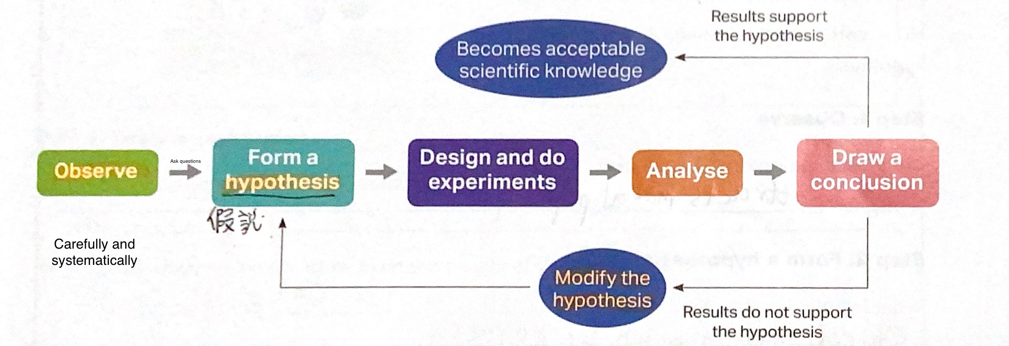

- Science is based on evidence. Scientists find evidence. If there is
enough evidence, the hypothesis is believed to be correct.
- Science process skills
  - Observing
  - Classifying
  - Designing investigations
  - Doing experiments
  - Inferring
  - Communicating
- Fair test
  - When designing an experiment, we have to make sure that it’s a fair test.
  - E.g. Which tissue is tougher
Independent variable  (The variable to be changed)(Usually 1) | Dependent variable  (The variable to be measured)(Usually 1) | Control variables  (Variables that are controlled the SAME)
brand of tissue | Weight it can hold | length of tissue paper  Width of tissue paper

- type of scientific investigations
  - fair tests：doing experiments
  - Classifying：sorting things into groups
  - Pattern seeking：finding a pattern
  - Model building：represent objects that are too small or too big - > building models

1.3 Laboratory safety

The science laboratory
- In studying science, you will do a lot of experiments in the laboratory.
- safety equipment -> protect our safety when doing experiments
- Laboratory safety equipment
  - Laboratory coat
  - Safety goggles
  - Protective gloves
  - Fire blanket
  - Fire extinguisher
  - Sand bucket
  - Eye wash bottle
  - First aid box
  - Fume cupboard
- There are many potential dangers in the laboratory
Laboratory safety rules
DOs
- Always follow the instructions given by your teacher.
- Know the fire escape route.
- Read safety precautions before doing an experiment.
- Wear safety goggles when heating or mixing substances.
- Tie up long hair and tuck in school ties when doing experiments.
- Wash your hands after completing an experiment.
- Keep the laboratory clean and tidy
- Report all accidents to your teacher immediately.
DON’Ts
- Do not enter the laboratory without your teacher's permission.
- Do not run or play in the laboratory.
- Do not eat or drink in the laboratory.
- Do not smell or taste any chemicals unless your teacher asks you to do so.
- Do not touch hot apparatus.
- Do not throw solid wastes into the sink.
- Do not point test tubes containing boiling liquids towards yourself or other students.
Hazard warning symbols
- Flammable
  - Keep away from heat and flame
- Explosive
  - Keep away from heat and flame
  - Avoid shock
- Corrosive
  - Wear safety goggles and protective gloves
  - Store in a well ventilated room
- Toxic/Harmful/Irritant
  - Avoid breathing in the Vapor of the chemical
  - Wear safety goggles and protective gloves
  - Wash your hands after handling the chemical
Handling some common laboratory accidents
- Cuts→clean the wound with water and apply a dressing to it
- Heat or chemical burns→place the affected area under slow running water
- Chemicals get into the eyes→wash the eyes with distilled water from a eye wash bottle
- Glass breakage→clean up broken pieces of glass and dispose them in a broken glass container
- Gas leakage→turn off the gas supply and open all windows and doors
- Fires→keep calm and report to your teacher at once; do not put out the fire by yourself
Handling a fire in the laboratory
- A fire triangle
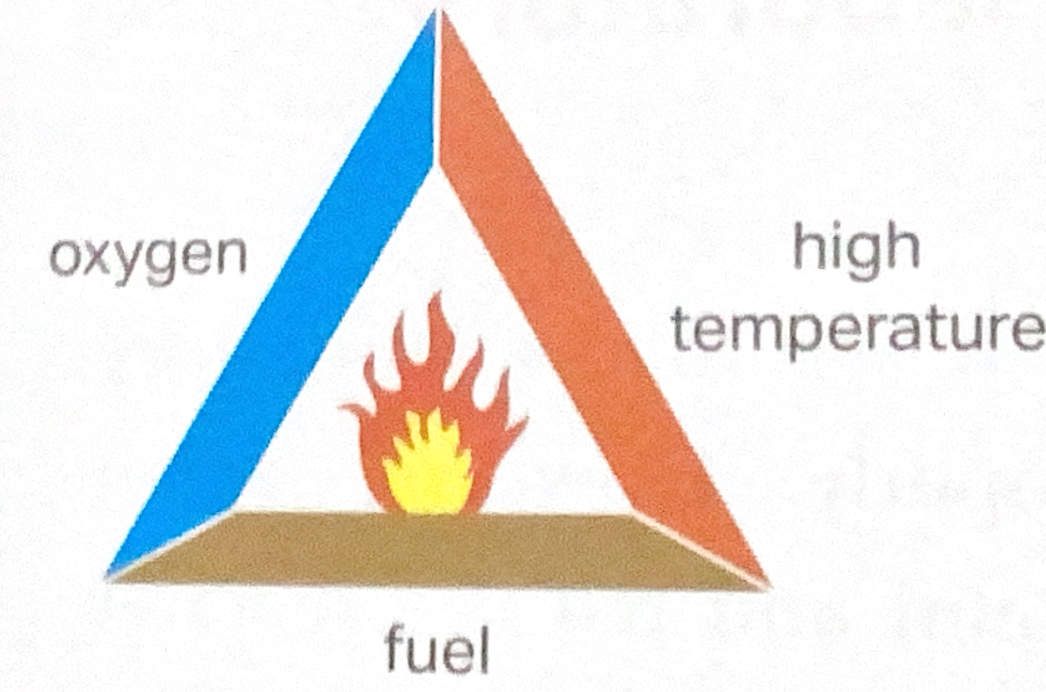
- Without any one of these conditions, the fire triangle cannot be formed and the fire will go out
- Fire extinguisher PASS technique (pull safety pin, aim at the lowest part of the fire, Squeeze the handle, Sweep from side to side until the fire is completely put out)

1.4 Laboratory apparatus
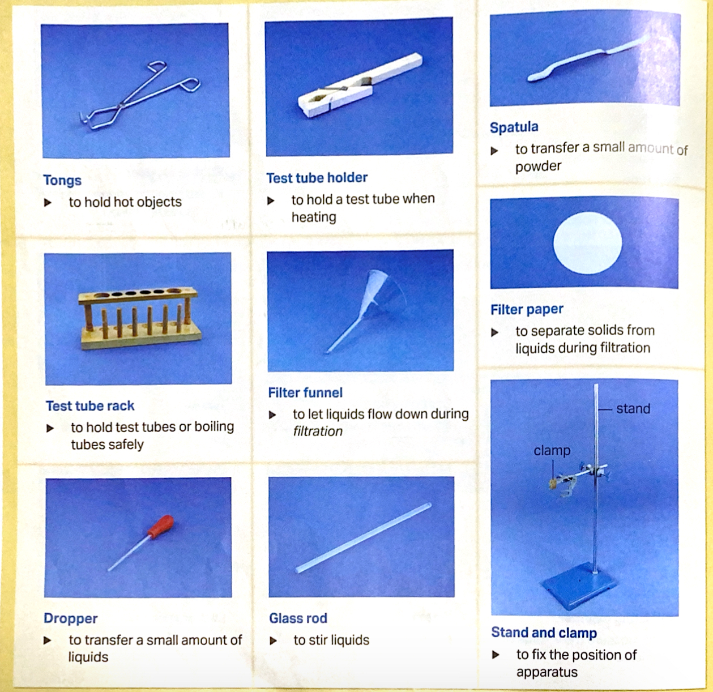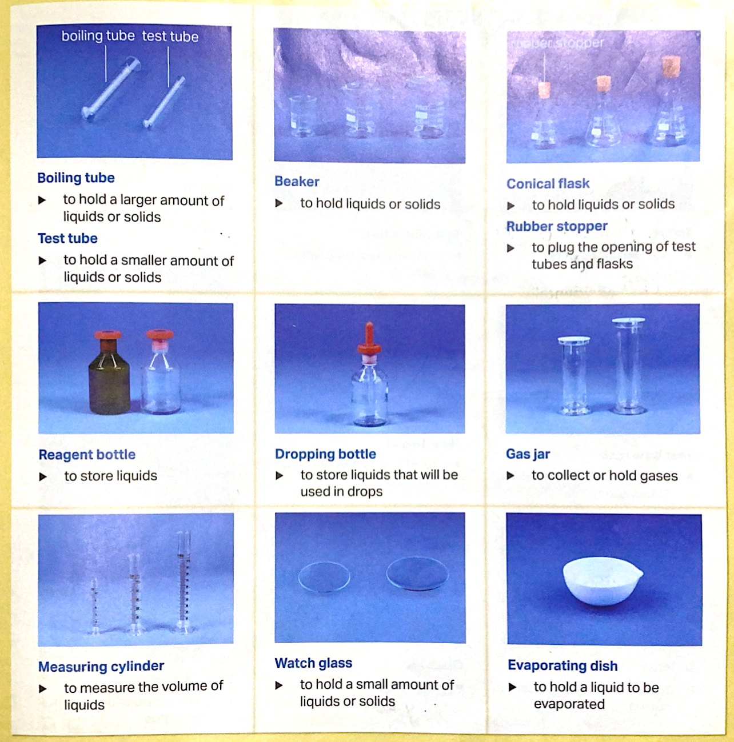

Vertical section diagram
- To show the experimental setup
- Draw with a pencil and ruler
- Do not shade
- Keep parts in portion
- Label all the apparatus
- Make sure the diagram is large enough so each piece of apparatus is clear
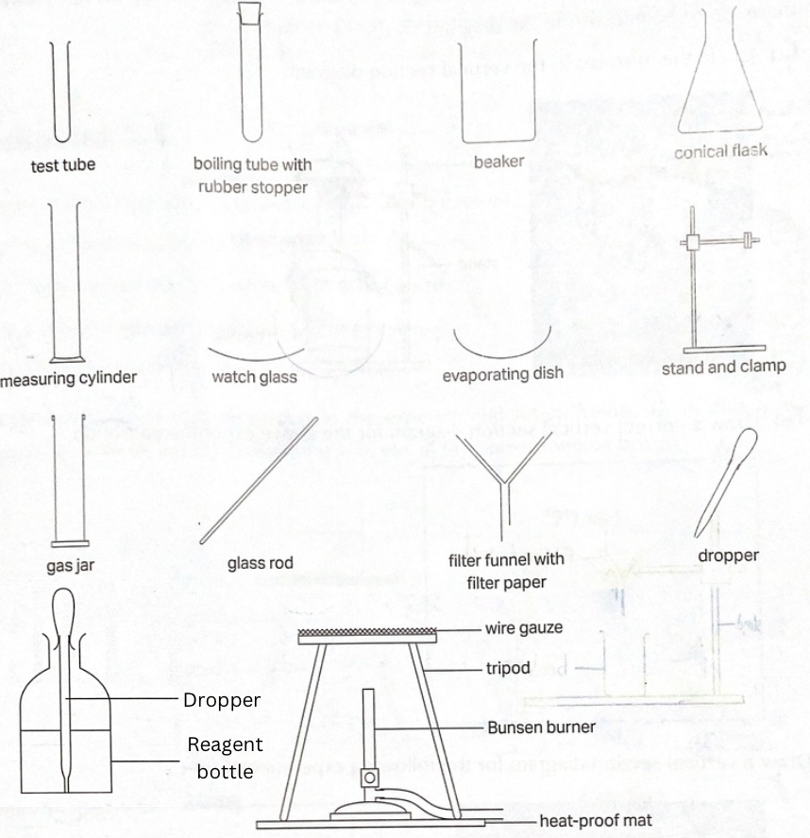

1.5 Using measuring instruments
Length
- Tool to measure
  - Meter rule
  - Half-meter rule
  - Measuring tape
- Unit
  - Meters (m)
  - Centimetres (cm)
  - Millimetres (mm)
  - Kilometres (km)
- Read the scale to the side -> take an accurate reading
Volume
- Unit
  - Millilitres (mL)
  - Litres (L)
  - Cubic centimetres (cm³)
  - Cubic meters (m³）
- Ways to measure
  - We use a measuring cylinder to measure the volume of a liquid
    - 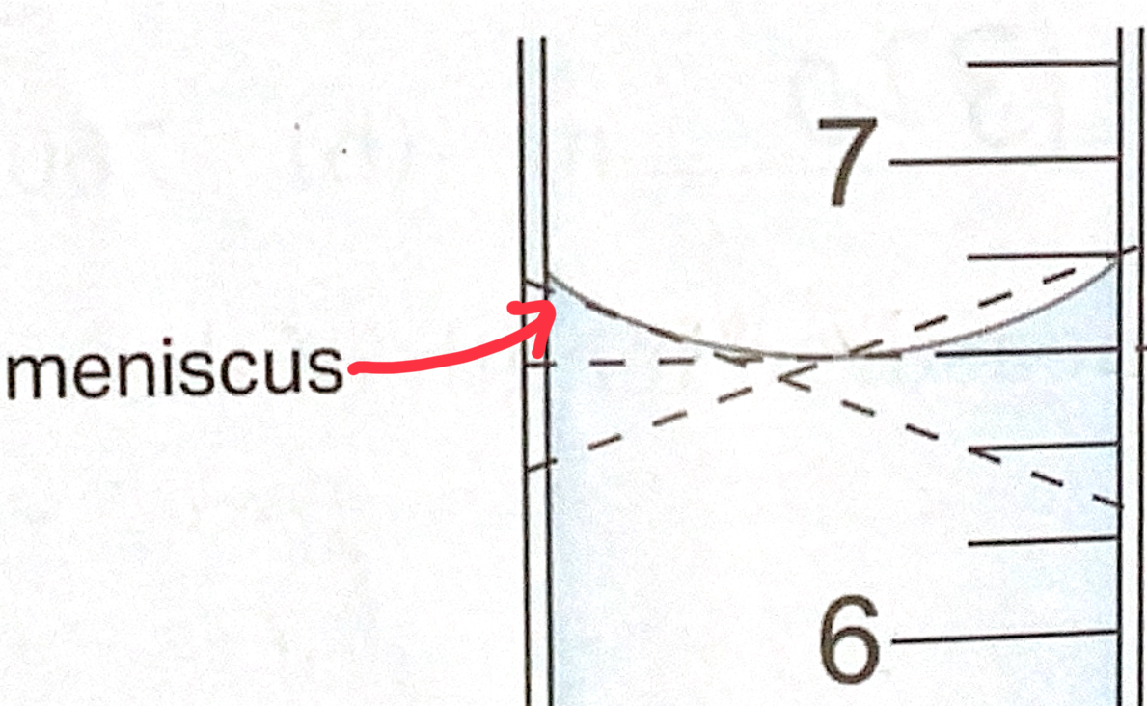
    - Eyes should be at the same level as the bottom of the meniscus-> take a accurate reading
  - Regular shaped objects’ volume can be found by calculation
    - Volume = length x width x height
Mass
- Unit
  - Kilograms
  - grams
  - milligrams
- Tool to measure : balance
  - Triple beam balance (has a precision of 0.1g)
  - Spring balance
  - Lever balance
  - Top pan balance (has a precision of 10g)
  - Electronic balance (has a precision of 0.01g)
    - How to use
- Put empty container
- Press re-zero
- Add the substance -> measure the weight
temperature
- Unit : degree Celsius
- Tool to measure :
  - Thermometer
  - Coloured alcohol thermometer
  - Mercury thermometer
  - Temperature sensor connected to a data logger (can be transferred to computer) gives prescient measurement
Time
- Unit :
  - Seconds (s)
  - Minutes (min)
  - Hours (h)
- Tools to measure
  - Stopwatch -> measure time as accurately as up to one hundredth of a second
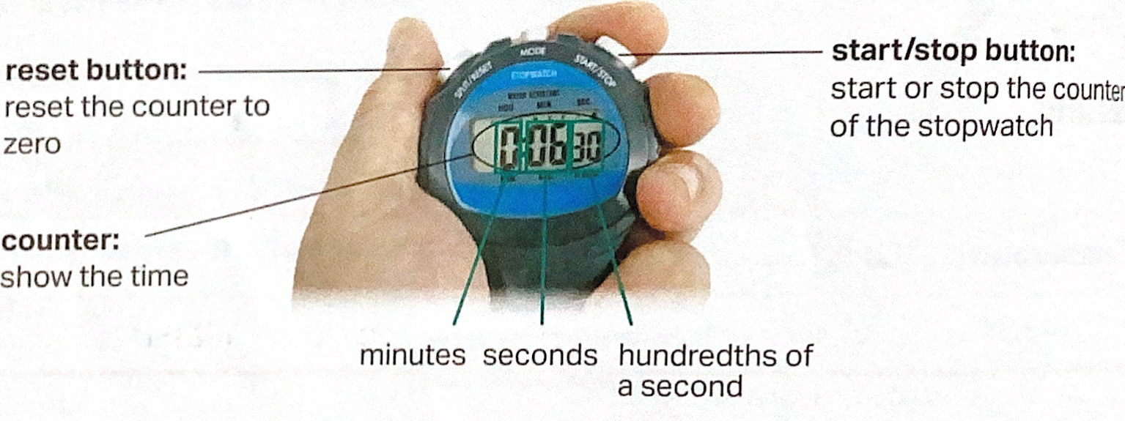
Making repeated measurements
- There are error when we make measurements
- Might be slightly different each trial
- The reaction time is different
- Repeat several time and find an average value

1.6 Basic practical skills
Transferring solutions
- Large amount : pour it out directly
- Small amount : use a dropper
- A dropper helps us control the amount of solution to transfer more easily
Mixing solutions
- Use a glass rod to stir the mixed solution in beaker
- Gently shake the test tube
- Tap the bottom of the test tube with the index finger
- Stopper the test tube and shake well
Heating
- We use a Bunsen burner to heat substances
- 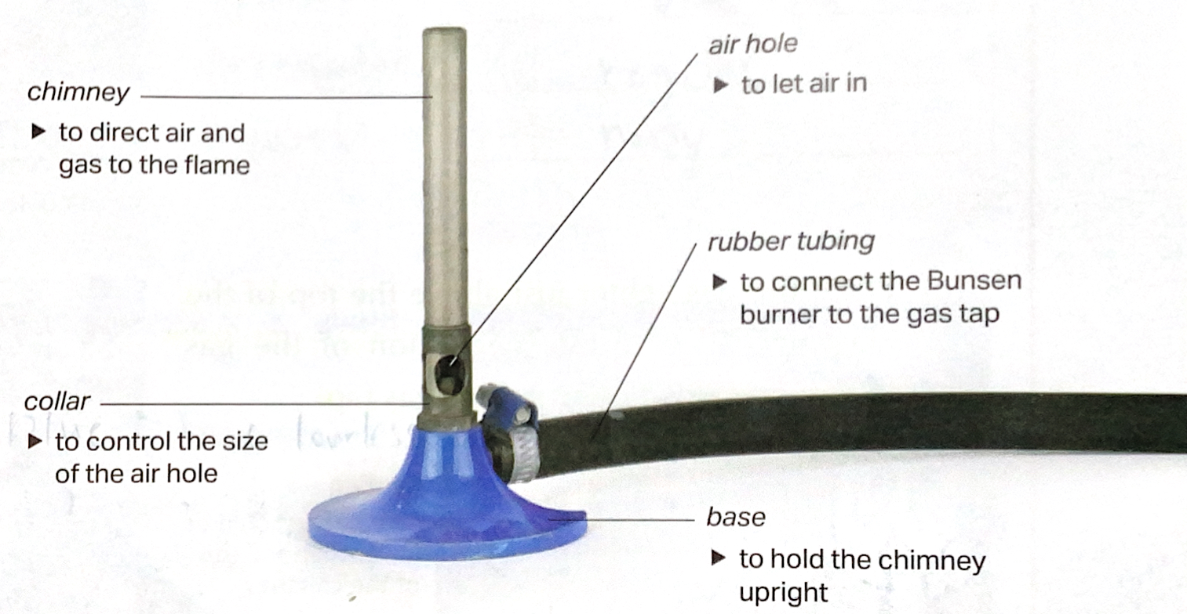
- Lighting a Bunsen burner
- Put it on a heat-proof mat
- Close the air hole
- Place a gas lighter just above the chimney
- Press the button of the lighter and turn on the gas tap
- Open the air hole slowly
Luminous flame | Non-luminous flame
air hole closed | air hole open
yellow | blue
irregular in shape | regular in shape
quiet | noisy
Lower temperature | Higher temperature
- Strike back
  - A Bunsen burner may strike back if the air hole is fully open while lighting a Bunsen burner
  - Observe a green flame
  - Hear a hissing sound
  - Turn off the gas tap immediately
- Heating a boiling tube
- Use a test tube holder to hold the test tube
- Heat by swirling the boiling tube over a non-luminous flame

Chapter 2 water

🐧Penguin’s notes🐧

2.1 The water cycle
- Water covers 70% of earth’s surface
Change in states of water
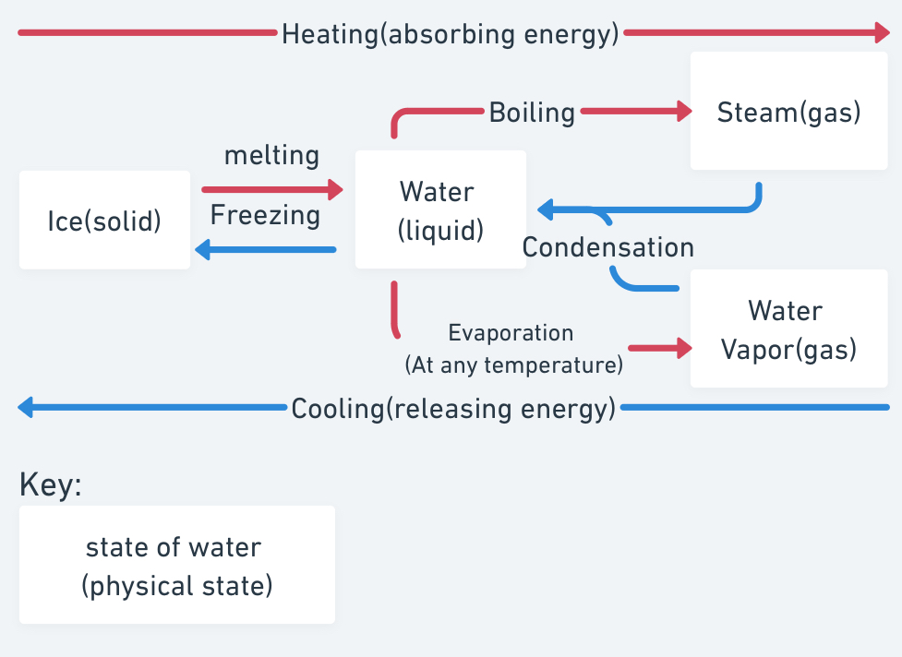
Water cycle
- Sun powers the water cycle
- Evaporation: Water in seas, river, etc. absorbs the energy from the sun>evaporates to form water vapor
- Condensation: water is cooled->condenses to forms water droplets->joined to form clouds
- Clouds may be carried by wind to other places
- Water droplets in cloud get heavier and larger->fall as rain, snow or hail
Factors affecting the rate of evaporation
The rate of evaporation increases when
- Higher temperature
- Lower humidity
- More airflow
- Larger surface area exposed

2.2 Dissolving
Solute, solvent and solution
- Solute breaks down into many small pieces that we can’t see->dissolves
- Solute dissolves in solvent to form a solution.
- E.g. Sugar (solute) dissolves in water (solvent) to form sugar water (solution).
- Able to dissolve in water -> soluble in water
  - Sugar and salt
- Not able to dissolve in water -> insoluble in water
  - Sand and flour
- Water can dissolve many different substances->Water is a universal solvent
Factors affecting the rate of dissolving
The rate of dissolving increases when
- The solution is stirred
- The temperature of the solvent is higher
- The surface area of the solute is larger
Solubility
- Solubility the limited amount of the solute which can dissolve in a given amount of solvent
- Different substances have different solubility in water
- The solubility of a substance changes with the temperature of solvent (higher or lower)

2.3 Water purification
The importance of water
- All form of life contain water
- We use water for many things
Impurity in natural water
- Natural water contains impurities
  - Insoluble impurities
  - Soluble impurities
  - Microorganisms (e.g. E. coil)
    - Some are harmful to us
Methods of water purification
- Sedimentation
  - Can remove heavy insoluble impurities
  - 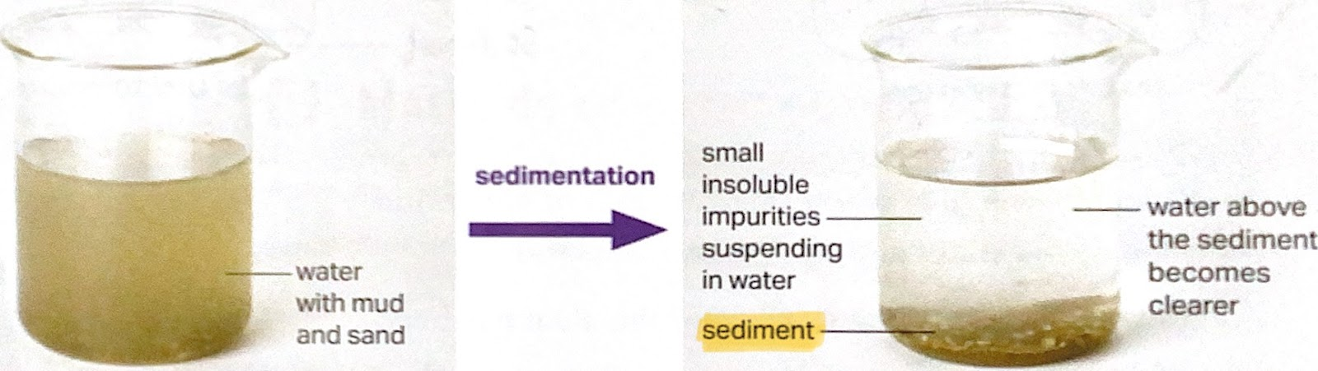
  - The heavy insoluble impurities that sank to the bottom is sediment
- Filtration
  - Can remove insoluble impurities.
  - 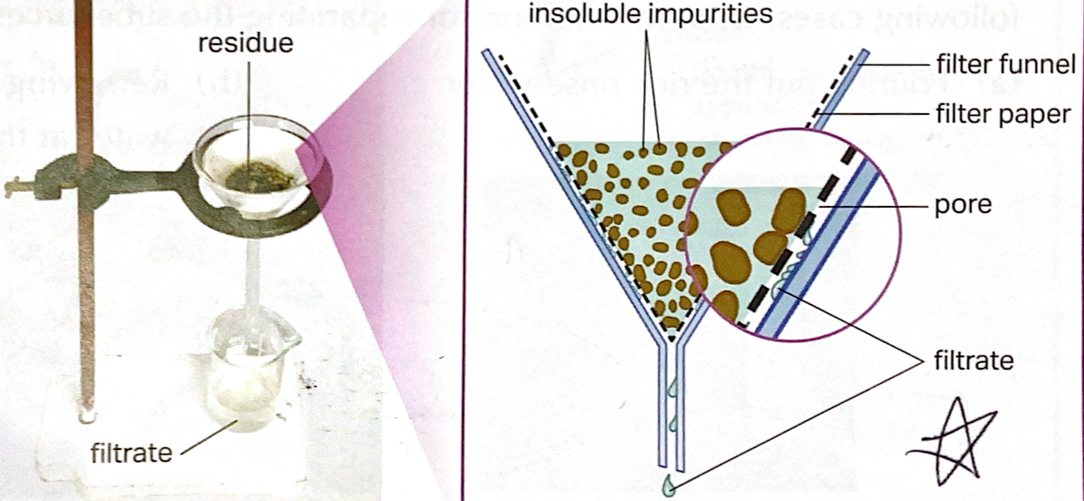
  - Cannot pass through the pores->residue
  - Passes through the filter paper->filtrate
    - Soluble impurities and microorganisms can pass through
- Distillation
  - Can remove insoluble and soluble impurities and microorganisms
  - 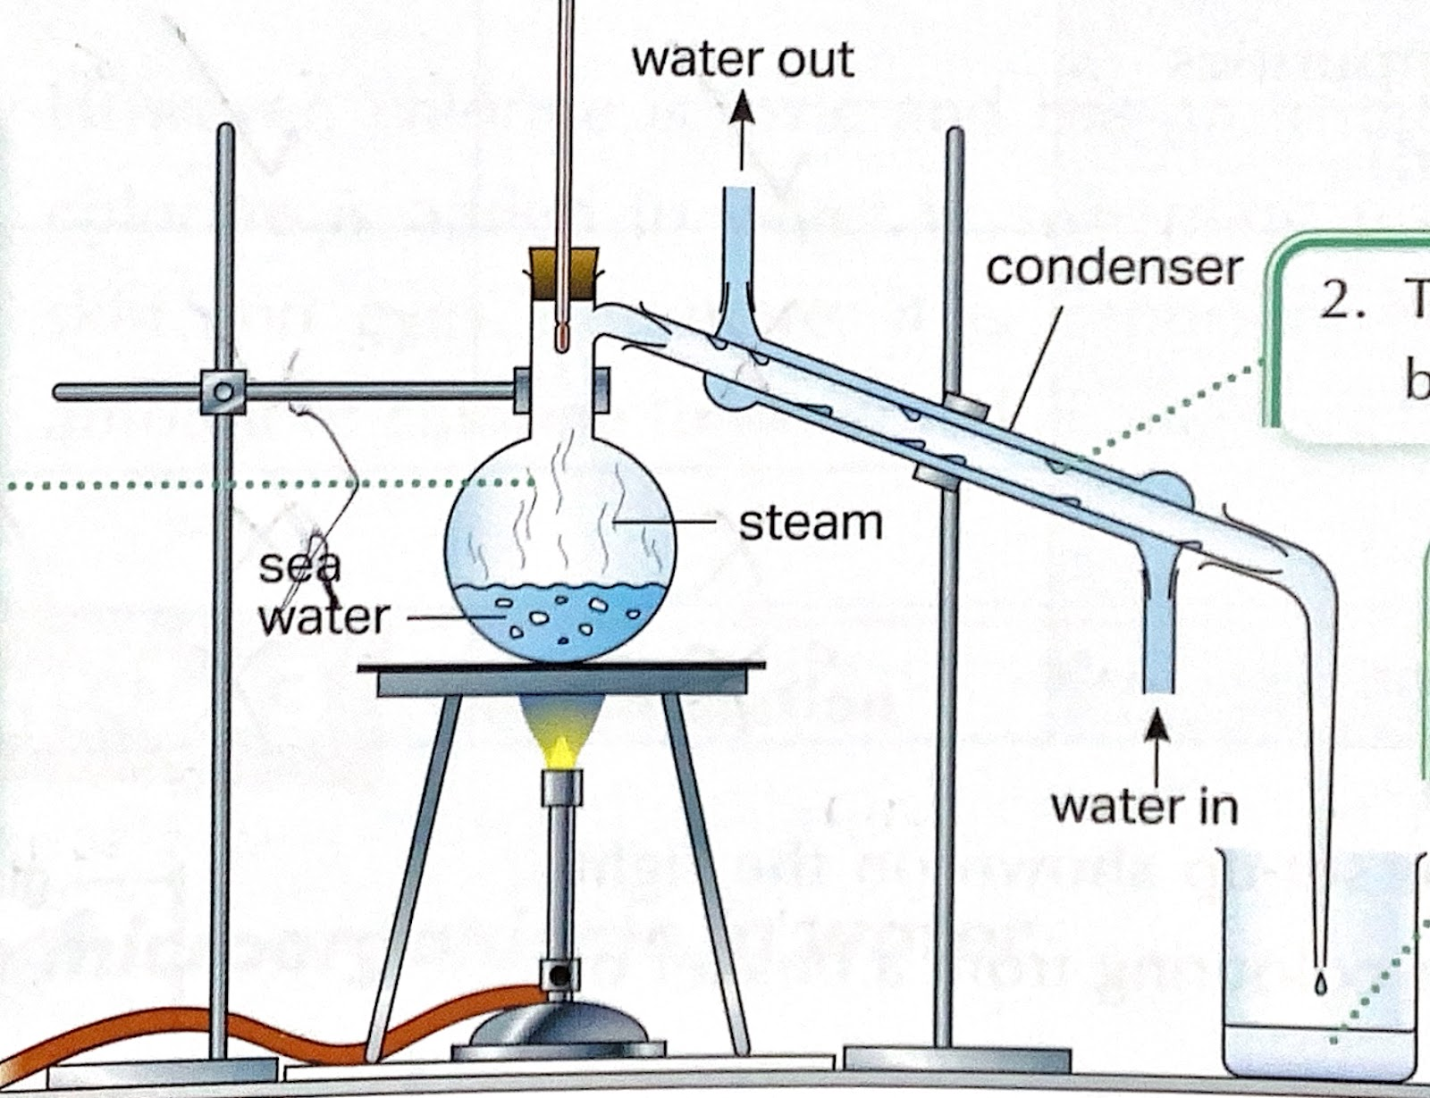
- Water boils to steam ->kills microorganisms and leave other impurities
- steam condenses to water
- water collected is called distilled water

2.4 Further treatment of water
 | Chlorination  (adding chlorine) | Adding ozone | Using ultraviolet light
Can | Kill microorganisms in water
Pros | cheaper | More effective
Cons | Have a irritating smell  May irritate skin and eye | More expensive
Useage | Swimming pools, some water treatment plants |  | Portable water filters, drinking fountains, aquariums

Fluoridation
- Adding fluoride
- Added to water to prevent tooth decay
- A common ingredient in toothpaste

2.5 Water purification
In Hong Kong
- 70%-80% of fresh water comes from Dongjiang water
- 20%-30% comes from rainwater from reservoirs
- Both treated in water treatment works
Water treatment 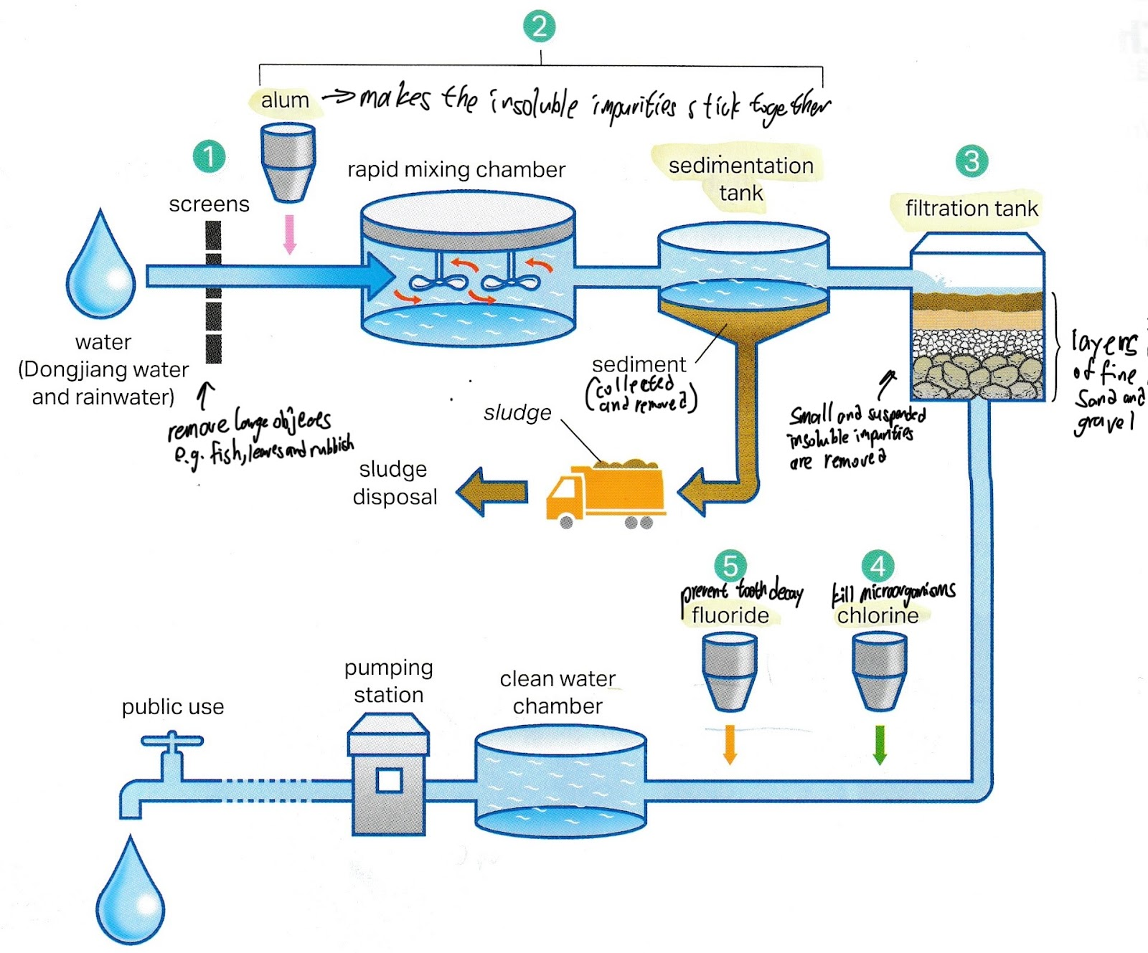

2.6 Water conservation and pollution
- 3% of water on earth is freshwater, 0.4%is in rivers and lakes
- In many parts of the world, fresh water supply cannot meet our needs
- Fresh water is a precious resource
conservation of water
- Take a short shower instead of a bath or a long shower
- Run the washing machine only when you have a full load
Water pollution
- Human activities produce pollutants
- If discharged in river, lakes or seas, they may cause water pollution
- Waste water
Homes | detergents, food and human waste
Restaurants | detergents, food waste, cooking oil
farms | animal waste, pesticides, fertilisers
factories | toxic chemicals such as heavy metal
  - Harmful effects
    - Human waste, animal waste, detergent and fertilisers promote the growth of algae
    - They use up the oxygen in water → Fish and other aquatic life may die to suffocation
    - Pesticides and toxic chemicals cause harmful effects to all life forms
- Littering and dumping of solid waste
  - Solid waste e.g. plastic bags, bottles, fishing nets
  - Along beaches and in rivers and seas
  - Harmful effects
    - Be hazardous to animals
    - Get trapped in fishing nets
    - Mistake plastic for food
- Oil spill accidents
  - Oil from accident spills of tanker ships->serious pollution
  - Harmful effects
    - Oil floats on water and prevents oxygen from dissolving into the sea water
    - Birds cannot fly when their feathers are covered with oil
    - Feathers cannot keep them warm
- Controls over water pollution
  - Take part of a beach cleaning campaign
  - Do not throw rubbish into seas and onto beaches
  - We have responsibilities
The importance of treating waste water
- Drainage Services Department is responsible for the treatment of waste water
- Harmful chemical waste is sent to Chemical waste treatment centre
- Harbour Area Treatment Scheme improved the water quality of Victoria harbour, E. coil libel has reduced

Chapter 3 living things

🐧Penguin’s notes🐧

3.1 Living things
There are living things and non-living things
- Vital functions of living things
  - Nutrition
  - Sensitivity
  - Respiration
  - Excretion
  - Movement
  - Reproduction
  - Growth
- These seven vital functions are common to all living things
- Non living things may have some functions similar to the vital functions of living things, but not all
Wide variety of living things
- Living things are also called organisms
- Microorganisms
  - Mould
- Animals
  - Blue whale
  - Ostrich
- Plants
  - Fern(does not produce flowers)

3.2 Classification
The need for grouping living thing
- We organise objects by grouping similar objects together. This is called classification
- Classification help us identify and study living things systematically
- Observe the key features in living things
- Put living things with similar key features in the same group
- Give the group a name
Using a key to identify living things
- Scientist make a key based on the key features of living things
- We should choose features that do not change over time for a key
- Key diagram
- 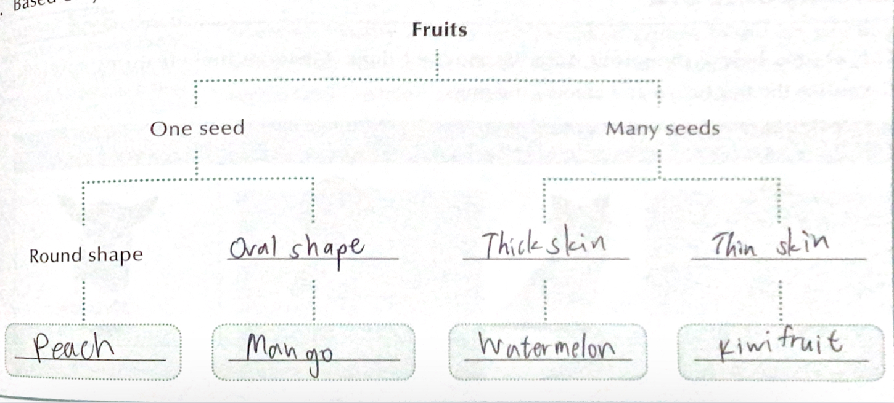
Classifying animals
- Invertebrates -> Don’t have backbone
- Vertebrates -> Have backbone
 | Habitat | Body features | Reproduction
Fish | Water | Have slimy scale, gills, fins, body temperature not easily affected by the surrounding | Lay eggs in water
Amphibians | Fresh water and on land | young:have gills, adults:breath through lungs and skin | Lay eggs in fresh water
Reptiles | Land | Have hard and dry scales, lungs | Lay shelled eggs on land
Birds |  | Have feathers, lungs, beak, wings | Lay shelled eggs on land
Mammals |  | Have hair, mammary glands that produce milk for feeding the young, body temperature not easily affected by the surrounding | Give birth to live young
Classifying plant
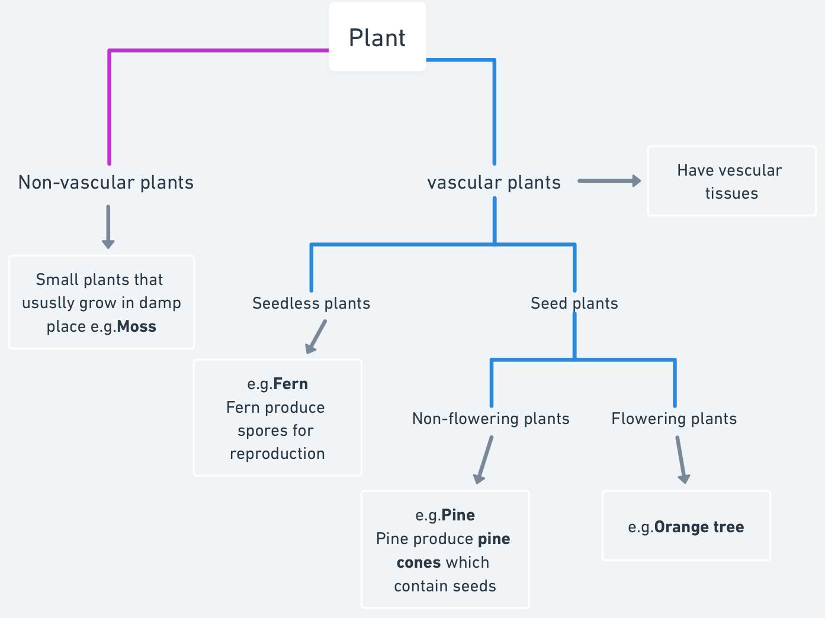
- Vascular tissues transports water, nutrients and mineral

3.3 Living things and habitat
- Habitat->where a living thing lives in a natural environment
- Adaptation-> Special body features that help them survive in their habitat
E.g.for grassland-> cheetah
- Hair colour and spotted pattern->provide camouflage
- good eyesight->make finding prey easier
- Sharp claws and teeth->for catching prey
- Long, strong legs->Allow it to run fast
Habitats
- Polar region
- Ocean
- Wetland
- Freshwater pond
- Tropical rainforest
- Desert

